**SC2002 OBJECT-ORIENTED DESIGN & PROGRAMMING**

**CAMP APPLICATION AND MANAGEMENT SYSTEM**

**Report of Project Structure Design & Functionality**

**AY2023/24 Sem 1, SCMC, Group 5**

|  |  |
| --- | --- |
| **GROUP MEMBERS** | **MATRICULATION NUMBER** |
| Neo Zhi Xuan | U2222293E |
| Samuel Tan | U2223180G |
| Seow Ming Han Samuel | U2220546F |
| Tan Jun Yan Xavier | U2221653J |
| Willy Tang Jing Lin | U2222170F |

**GitHub Main Page:** [**https://github.com/dysfunkt/SC2002_Assignment_CAMs**](https://github.com/dysfunkt/SC2002_Assignment_CAMs)

## Declaration of Original Work for SC/CE/CZ2002 Assignment

We hereby declare that the attached group assignment has been researched, undertaken, completed, and submitted as a collective effort by the group members listed below.

We have honoured the principles of academic integrity and have upheld Student Code of Academic Conduct in the completion of this work.

We understand that if plagiarism is found in the assignment, then lower marks or no marks will be awarded for the assessed work. In addition, disciplinary actions may be taken.

|  |  |  |  |
| --- | --- | --- | --- |
| **GROUP MEMBERS** | **COURSE** | **LAB GROUP** | **SIGNATURE** |
| Neo Zhi Xuan | SC2002 | SCMC |  |
| Samuel Tan | SC2002 | SCMC |  |
| Seow Ming Han Samuel | SC2002 | SCMC |  |
| Tan Jun Yan Xavier | SC2002 | SCMC |  |
| Willy Tang Jing Lin | SC2002 | SCMC |  |

# 1 APPLICATION OVERVIEW

Camp Application and Management System (CAMs) is a Java console application designed for staff and students to manage, view and register for camps within NTU. The application acts as a centralised hub for all staff and students.

# 2 ASSUMPTIONS MADE

We made some assumptions in our application to facilitate a smoother flow. Firstly, we assume that deleting an object completely removes it from our database, to maintain security of the system. Secondly, we assume that *Staff* can create multiple camps. Thirdly, we assume that users remember their user ID and password, as our CAMs would be synced to NTU systems similar to LDAP Login.

# 3 DESIGN APPROACH

CAMs was designed with the aim of providing extensibility, maintainability and reusability, through the use of various SOLID and Object-Oriented Programming principles, to ensure our software design is efficient and understandable. We also aim to make the application as user-friendly as possible.

## 3.1 SOLID Principles

### 3.1.1 Single Responsibility Principle (SRP)

The Single Responsibility Principle (SRP) states that each class should have a clear, singular responsibility of its own - each class should be responsible for its own methods.

For example, we have implemented a few classes within our application to deal with specific functions. Our *Boundary* class deals solely with printing outputs and user interaction. Our *Controller* class deals solely with input storage. Our *Model* class is where objects are created from.

### 3.1.2 Open/Closed Principle (OCP)

The Open/Closed Principle (OCP) states that classes should be open for extension but closed for modification. For example, we created an abstract class *Repository<Model>*, which can be extended into different kinds of Repositories such as *CampRepository* or *EnquiryRepository*. *Repository* includes file I/O methods, which are usable by all its subclasses. Should we want to create a repository for a new *Model* item, we can easily extend from the base *Repository* class without modifying the original *Repository* implementation.

### 3.1.3 Liskov Substitution Principle (LSP)

The Liskov Substitution Principle (LSP) states that subclasses must be substitutable for their base class. If class A is a subclass of class B, we should be able to replace B with A without disrupting program behaviour.

For example, the team has implemented the *BaseUI* class, with many menu UI classes inheriting from the *BaseUI* class. The inherited classes behave as expected of the *BaseUI* – to ensure the menu flow of each function of the CAMs is run smoothly, containing its own ability, no more and no less.

### 3.1.4 Interface Segregation Principle (ISP)

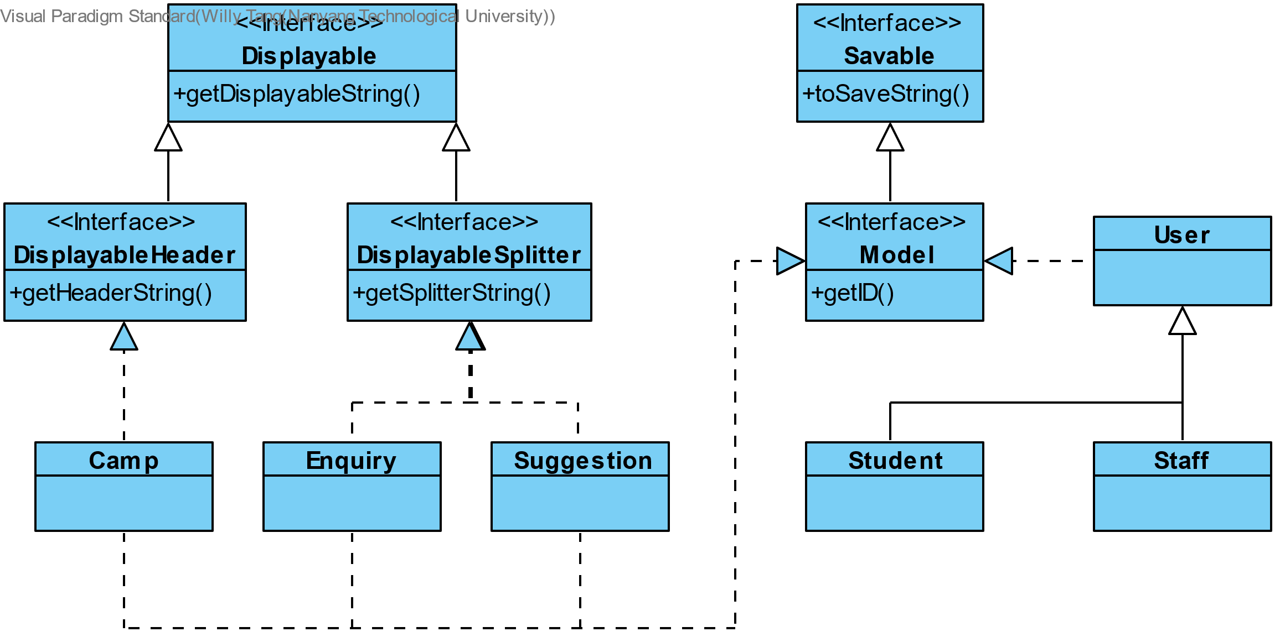The Interface Segregation Principle (ISP) states that having many specific interfaces is better than having one general interface.

For example, in our application, we have created the *Displayable* interface class. This allowed us to extend *DisplayerHeader* and *DisplayerSplitter*, each with their unique methods. *Displayable* interface defines *getDisplayableString()*, which allows objects to be displayed.

### 3.1.5 Dependency Injection Principle (DIP)

The Dependency Injection Principle (DIP) states that high-level modules should not depend on low-level modules, but instead they should both depend on abstractions.

For example, *Displayable* also serves to fulfil DIP, as we now depend on *Displayable* interface, which is less likely to be changed. We can create more subclasses extending from *Displayable* with the least effort needed in the future, making our application more extendable.

## 3.2 OBJECT-ORIENTED PRINCIPLES

### 3.2.1 Inheritance

Inheritance is a concept that allows subclasses to inherit attributes and functions from its superclass. This concept is prominent in our application, as many of our classes are derived from a base class, namely our *BaseUI* superclass which created all our UI Classes within the *Boundary* Class.

### 3.2.2 Encapsulation

Encapsulation is a concept where certain class attributes are only accessible through their accessor and mutator methods. This is to ensure their visibility is set to private/protected and hidden from other classes, or only be visible to subclasses or classes within the same package. Our *Model* classes demonstrate this by keeping its attributes private but providing accessor and mutator methods to modify it.

### 1.2.3 Polymorphism

Polymorphism is a concept that refers to the ability of a function, or object to take on multiple forms, based on the type of data being used in the method or class. We use “Method Overloading”, a concept of Polymorphism. For example, our *CampManager* class provides different ways to call the method *getListByFilter()*, which prints out a list of camps based on user choice. If the user wants to filter by Date, or Camp Location, he is thus able to. We also use “Method Overriding” to override the *generateMenuScreen()* function, so that each UI class will print a different menu when its *generateMenuScreen()* function is called*.*

## 3.4 FURTHER CONSIDERATIONS

These are some further improvements we made to our application beyond the given specifications. Firstly, users logging in for the first time are prompted to change their password. We made it so they are required to **create a strong password**: including uppercase, lowercase and numbers. This greatly enhances security of individual users in CAMS. Secondly, we implemented several **input validation features** in our application. Should users key in any value beyond the specified value, or a string instead of an integer, our error-checking will prompt the user again for a valid input.

Lastly, we strived to make our application **more user-friendly**. We split up the functions of the user into several menus, each serving its own purpose. This ensures that the user is not overwhelmed with a long list of options. Every time the user accesses a function that requires them to input a camp ID, we will display all available camps and their corresponding camp IDs, followed by allowing the user to input a camp ID by referring to that list. We ensure that the user does not have to scroll back up through our interface, or rely on their memory on which camp and camp ID they registered for, thus increasing ease of use.

# 4 REFLECTION

We reflected on some **possible improvements to CAMS** that we can implement in the future. Firstly, students who are unable to join a camp are put on a waitlist for that camp. If a registered attendee withdraws, the next person on the waitlist is automatically enrolled. This would ensure a fair, first-come-first-served policy instead of the student needing to constantly check on whether his preferred camp has an available slot. Secondly, we can notify students when their enquiries have been replied to. This can be in the form of a notification in the menu when the student logs in. Similarly, we can also notify camp committee members when new enquiries come in and staff when new suggestions come in. These changes make it more user-friendly.

Through this assignment, our team learnt a lot about the **importance of design principles** and how to apply them in real-world applications. At the start, we were unfamiliar with OOP design principles, and did not utilise much of it. We soon realised that modifying a class slightly would result in us having to change many other classes. Additionally, our classes became unbearably long and difficult to read. We decided to rebuild many of our classes from the ground up and by adhering to the SOLID principles closely, we managed to reduce the coupling amongst classes to make our program **flexible, easily maintainable, and extendable.**

This assignment is the first time for many of us that we are working on a large scale application as a group. As such, we have taken this opportunity to learn Git and Github. This made the process of synchronising progress a lot easier. This skill is timeless and will remain valuable/useful for the foreseeable future.

# 5 UML DIAGRAM

## 5.1 Main Diagram

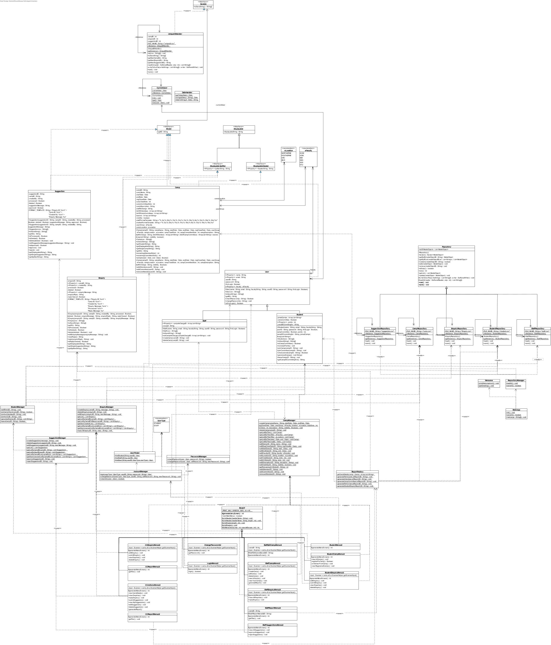

## 5.2 Entity Sub Diagram (Model + Repo)

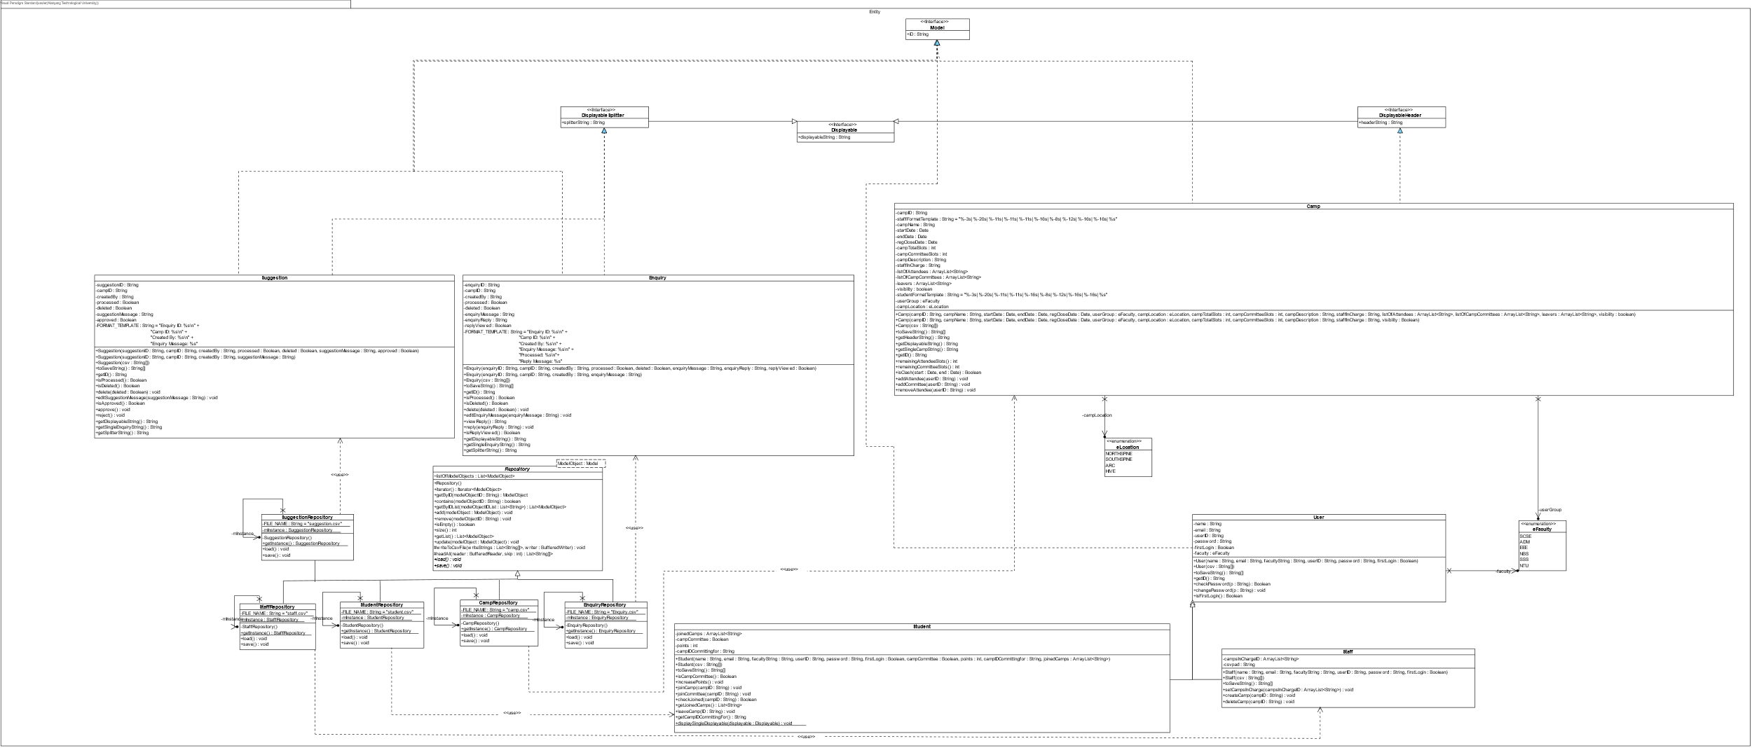

## 2.3 Controller Sub Diagram (by itself)

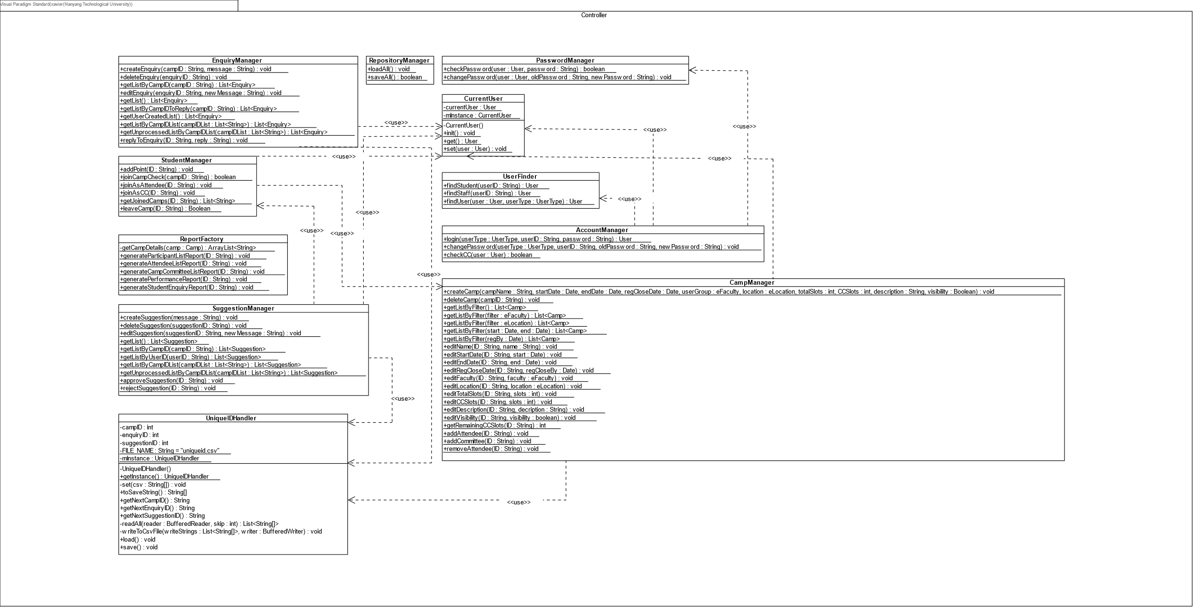

**2.4 Boundary Sub Diagram (all the UI)**

# 

# 3. TEST CASES

## 3.1 WELCOME PAGE

### 3.1.1 Login Page

|  |  |
| --- | --- |
| The User is able to view the Login page of our system.  They can proceed to login and choose whether to login as *Staff* or *Student*. |  |
| We use *Student* **KOH1** as an example. We check for valid Username and Password.  Upon successful first time login, we prompt the user to change password. |  |

### 3.1.2 Change Password

|  |  |
| --- | --- |
| The *Student* can still change his password again inside the app. |  |
| The user’s new password must have an uppercase, lowercase and a number. Otherwise, we will keep prompting.  Password changed successfully if conditions are met. |  |

### 3.1.3 Log Out

|  |  |
| --- | --- |
| Once done, the user can log out. They can then terminate the application.  Changes are saved and the application shuts down. |  |

## 3.2 STUDENT REGISTER AND WITHDRAW

### 3.2.1 Student view available camps

|  |  |
| --- | --- |
| *Student* can first view what camps he can register for. We use *Student* KOH1, Password1 as an example again.  *Student* can filter by View All, or other options like Location. |  |

### 3.2.2 Student register for a camp as either an attendee, or committee

|  |  |
| --- | --- |
| When registering, the list of available camps is printed again for reference.  *Student* can choose whether to register as an Attendee or Committee. Input must be 1 or 2 or it will keep prompting. |  |

### 3.2.3 Student withdraws from camp

|  |  |
| --- | --- |
| *Student* can withdraw from camp if he changes his mind.  We make sure that the Student is ONLY withdrawing from a camp he is registered for. If successful, he withdraws. If not, prompt again. |  |

## 3.3 CAMP COMMITTEE SUBMIT ENQUIRY AND SUGGESTION

### 3.3.1 Camp committee submit an enquiry

|  |  |
| --- | --- |
| Committee Enquiry/Camp Menu has all the same functions that Student has.  We login again as *Student* YCHERN, password Password1 to demonstrate this.  A *Camp Committee* is able to submit enquiries for any camp he can view, just like a *Student*.  After submitting an enquiry, he can view it again, edit it, or delete it.  He can check to see if a *Staff/Committee* has replied to his enquiry. |  |

### 3.3.2 Camp committee view camps he is committeeing for

|  |  |
| --- | --- |
| A *Student* who chose to register as a *Camp Committee* (see 3.2.2) has a NEW menu to choose from. (Option 3)  *Committee* is able to view camps he is committeeing for. |  |

### 3.3.3 Camp committee submit suggestion for his camp

|  |  |
| --- | --- |
| Committee is able to submit suggestions for his camp.  After submitting a suggestion, he can view it again, edit it, or delete it. |  |

### 3.3.4 Camp committee view and reply enquiries

|  |  |
| --- | --- |
| Committee is able to view all enquiries from students for his camp, and reply to them. |  |

### 3.3.5 Camp committee cannot quit camp

|  |  |
| --- | --- |
| Committee is not allowed to withdraw from a camp they are committeeing for.  Unsuccessful withdrawal. |  |

## 3.4 STAFF GENERATE CAMP REPORTS

### 3.4.1 Staff view all camps

|  |  |
| --- | --- |
| Now we use Staff HUKUMAR, Password1. Staff are able to view ALL camps, even those set to not visible. |  |

### 3.4.2 Staff view their own camps

|  |  |
| --- | --- |
| Staff can choose to view only their camps. |  |

### 3.4.3 Staff can generate a camp report

|  |  |
| --- | --- |
| Staff can generate a participant list.  Staff wants to see All Participants.  Staff wants to filter by Camp Committees only. |  |
| Staff can also generate a Committee’s performance report. |  |
| Staff can also generate Students’ enquiry report. |  |

## 3.5 STAFF CREATE AND EDIT CAMPS

### 3.5.1 Staff inputting camp details

|  |  |
| --- | --- |
| Staff are able to create new camps. From the Staff Camp Menu, we can choose to create a new camp. |  |
| Staff can create camps by inputting camp details into the system.  We do error-checking to make sure we can only have 10 camp committees.  Camp has been created successfully. |  |

### 3.5.2 Staff editing camp details

|  |  |
| --- | --- |
| Before editing, we print a list of camps that the Staff can edit. Staff cannot edit camps he has not created.  Staff can choose to change only the camp name specifically.  The new camp name is successfully updated. |  |

### 3.5.3 Staff delete camp

|  |  |
| --- | --- |
| When the delete-camp function is called, it shows a list of delete-able camps.  In case Staff changes his mind, he can choose N to cancel the delete.  If not, he can choose Y and delete the camp.  Camp has been deleted successfully. |  |